SIMATS ENGINEERING
ASSESSMENT TOOL 3

COURSE CODE: ITA0601 COURSE NAME: MACHINE LEARNING

COURSE OUTCOME COVERED

CO2: Neural Network Representation, Perceptron Model, Multilayer Perceptron’s, Backpropagation Algorithm, Deep Neural Networks, Genetic Algorithms, Hypothesis Space Search, Genetic Programming, Models of Evaluation and Learning (BL1, BL2)

Assessment Tool Weightage: 10%

QUESTIONS:15 Total Marks:25
Annexure A

DEBUGGING & OPTIMIZATION TASK QUESTIONS

Code of Conduct:

I __S.Sri Sai Prasanna Durga (192424241) (Name / Reg No) certify that this submission is my original work and that I have adhered to the guidelines specified for this assessment.
I understand that any violation of academic integrity rules will result in disciplinary action.

Signature of the student: S.Sai Prasanna

Annexure A

Short Answer Test

1. A perceptron model is trained on a dataset that is known to be linearly separable, yet the algorithm fails to converge even after many iterations. Analyze the possible causes of this issue, including improper learning rate selection, incorrect weight initialization, bias handling errors, or flawed implementation of the update rule. Propose debugging strategies to identify the root cause and suggest optimization techniques to ensure faster and stable convergence. (5 Marks)

Ans: A Perceptron is a simple supervised learning algorithm used for binary classification. It calculates the weighted sum of input features and uses an activation function to predict the class.
For a linearly separable dataset, a correctly implemented perceptron should eventually converge.
If the perceptron does not converge, possible reasons include an incorrect learning rate, improper weight initialization, incorrect bias handling, incorrect target values, or an incorrect weight-update equation.
Possible Causes:
1. Improper Learning Rate
The learning rate controls the size of each weight update.
- A very high learning rate can cause large and unstable updates.
- A very low learning rate can make convergence very slow.
- A value such as 0.01 or 0.1 can be used for a simple problem.
2. Incorrect Weight Initialization
Weights determine the initial position of the decision boundary.
If weights are initialized incorrectly or contain unexpected values, the training process may take longer.
For a simple perceptron, weights can safely be initialized to zero or small values.
3. Bias Handling Error
The bias allows the decision boundary to shift.
If the bias is not included or is not updated correctly, the perceptron may not classify the data correctly.
The bias update is:
where:
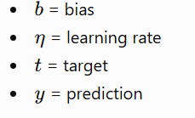
4. Incorrect Update Rule
The correct perceptron weight update is:
where:
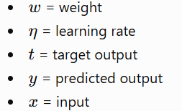
If the wrong formula is used, the weights may move in the wrong direction.
5. Incorrect Target Labels
The target values must match the activation function.
In this example, we use:
- +1 for positive class
- -1 for negative class
Sample Dataset:
Sample | Feature 1 (X1) | Feature 2 (X2) | Class (Y)
1 | 2 | 3 | +1
2 | 3 | 4 | +1
3 | 4 | 2 | +1
4 | 1 | 1 | -1
5 | 2 | 1 | -1
6 | 1 | 2 | -1
The positive and negative samples can be separated by a straight decision boundary.
Python Code:
import numpy as np
X = np.array([
[2, 3],
[3, 4],
[4, 2],
[1, 1],
[2, 1],
[1, 2]
])
y = np.array([1, 1, 1, -1, -1, -1])
learning_rate = 0.1
epochs = 20
weights = np.zeros(X.shape[1])
bias = 0
print("Initial Weights:", weights)
print("Initial Bias:", bias)
for epoch in range(epochs):
errors = 0
print("\nEpoch", epoch + 1)
for i in range(len(X)):
net_input = np.dot(X[i], weights) + bias
prediction = 1 if net_input >= 0 else -1
if prediction != y[i]:
weights = weights + learning_rate * y[i] * X[i]
bias = bias + learning_rate * y[i]
errors += 1
print("Input:", X[i],
"Target:", y[i],
"Prediction:", prediction)
print("Updated Weights:", weights)
print("Updated Bias:", bias)
print("Errors:", errors)
if errors == 0:
print("\nPerceptron Converged Successfully!")
break
print("\nTraining Completed")
print("Final Weights:", weights)
print("Final Bias:", bias)
print("\nTesting on Training Data")
for i in range(len(X)):
net = np.dot(X[i], weights) + bias
prediction = 1 if net >= 0 else -1
print("Input:", X[i],
"Actual:", y[i],
"Predicted:", prediction)
Output:
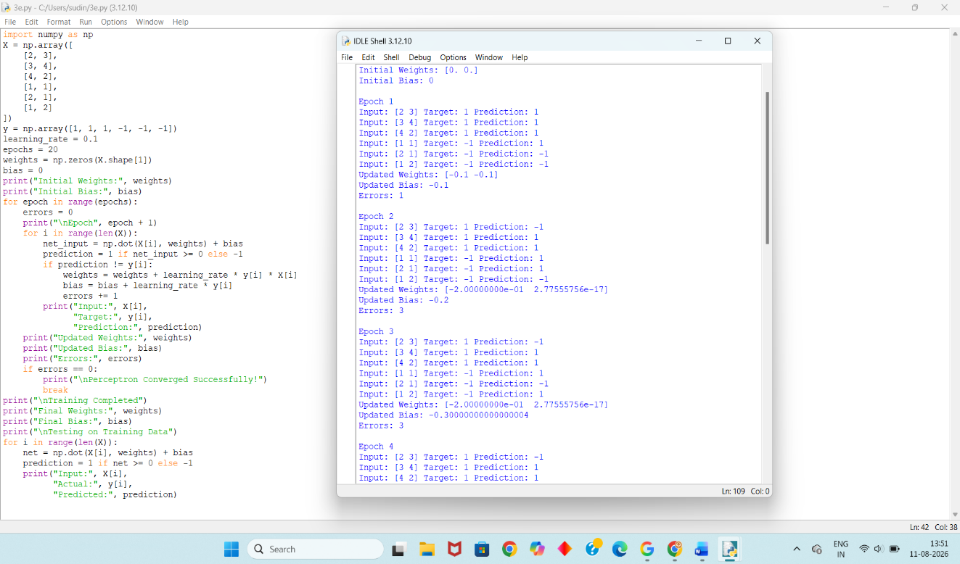
Debugging Strategies:
1. Verify the Perceptron Update Rule
Check that the following equation is correctly implemented.
2. Check the Bias
Verify that the bias is included in:
net_input = np.dot(X[i], weights) + bias
and updated correctly.
3. Check Predictions
Print the:
- Input
- Target
- Prediction
- Error
after every iteration.
4. Check the Dataset
Make sure:
- Input values are correct.
- Target labels are correct.
- The dataset is actually linearly separable.
5. Test on a Small Dataset
First test the program with only a few samples. This makes it easier to identify errors in the update rule.
Optimization Techniques:
- Select a suitable learning rate such as 0.01 or 0.1.
- Initialize weights with zeros or small random values.
- Normalize input features when feature values have very different scales.
- Shuffle the training samples before each epoch.
- Stop training when the number of errors becomes zero.
- Set a maximum number of epochs to prevent unnecessary computation.
Conclusion:
A perceptron should converge when the dataset is linearly separable and the algorithm is correctly implemented. By checking the learning rate, weight initialization, bias, target labels, and update rule, the root cause of non-convergence can be identified. Proper initialization, normalization, parameter tuning, and early stopping help the perceptron converge faster and more reliably.

2. While training a multilayer perceptron using the backpropagation algorithm, the network exhibits slow convergence and gets stuck in local minima. Examine the potential reasons such as vanishing gradients, inappropriate activation functions, poor weight initialization, or suboptimal learning rates. Describe step-by-step debugging approaches to trace the issue and recommend optimization techniques like adaptive learning rates, normalization, or advanced optimizers to improve performance.
(5 Marks)
Ans: A Multilayer Perceptron (MLP) is a neural network containing an input layer, one or more hidden layers, and an output layer.
The backpropagation algorithm calculates the error and propagates it backward through the network to update the weights.
Slow convergence can occur because of:
- Vanishing gradients
- Poor activation functions
- Poor weight initialization
- Incorrect learning rate
- Unnormalized input data

Possible Causes:

1. Vanishing Gradients
In deep networks, gradients can become extremely small while moving backward through the layers.
As a result, earlier layers receive very small updates and learn slowly.

2. Inappropriate Activation Function
Sigmoid and tanh can produce very small gradients when their input values become very large or very small.
Using ReLU in hidden layers can help reduce this problem.

3. Poor Weight Initialization
Very large or very small initial weights can make learning unstable.
Suitable initialization helps the network start learning effectively.

4. Incorrect Learning Rate
A very small learning rate causes slow learning.
A very high learning rate can cause the loss to jump up and down.

5. Unnormalized Input
Features with very different scales can make optimization difficult.
Normalization or standardization improves training.
Sample Dataset:
For demonstrating nonlinear learning, the XOR dataset can be used.
Sample | X1 | X2 | Target
1 | 0 | 0 | 0
2 | 0 | 1 | 1
3 | 1 | 0 | 1
4 | 1 | 1 | 0
XOR cannot be solved by a single perceptron, but an MLP can learn it.
Python Code:
from sklearn.neural_network import MLPClassifier
from sklearn.preprocessing import StandardScaler
from sklearn.pipeline import make_pipeline
X = [
[0, 0],
[0, 1],
[1, 0],
[1, 1]
]
y = [0, 1, 1, 0]
model = make_pipeline(
StandardScaler(),
MLPClassifier(
hidden_layer_sizes=(4,),
activation="relu",
solver="adam",
learning_rate_init=0.01,
max_iter=2000,
random_state=42
)
)
model.fit(X, y)
predictions = model.predict(X)
print("MULTILAYER PERCEPTRON")
print("---------------------")
print("Actual Values: ", y)
print("Predicted Values:", predictions)
accuracy = model.score(X, y)
print("\nTraining Accuracy:",
round(accuracy * 100, 2), "%")
print("Training Completed Successfully")
Output:
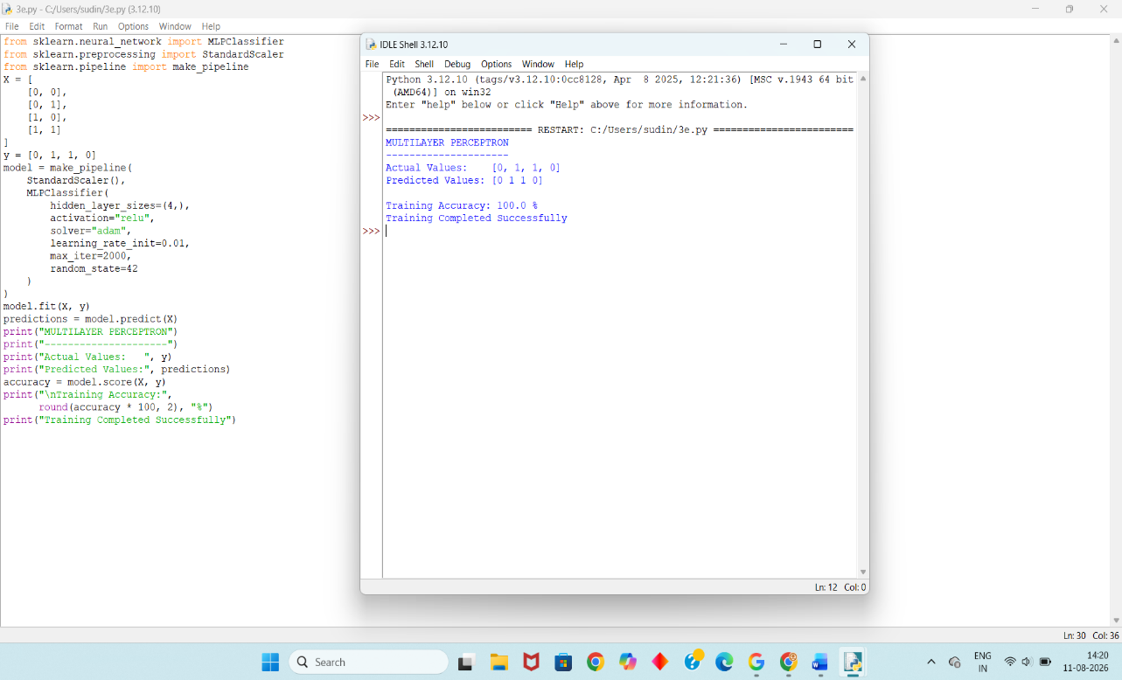
Debugging Strategies:
Step 1 – Check the Input Data
Verify that:
- Input values are correct.
- Target labels are correct.
- No missing values exist.
Step 2 – Normalize the Data
Use: StandardScaler()
This makes the input features suitable for optimization.
Step 3 – Check Activation Functions
Use ReLU for hidden layers:
activation="relu"
Step 4 – Check the Learning Rate
Try values such as:
0.001
0.01
0.1
and compare convergence.
Step 5 – Monitor Loss
If the loss remains constant, there may be a problem with:
- Learning rate
- Initialization
- Activation function
- Input data
Step 6 – Check the Number of Hidden Neurons
Too few neurons may underfit the problem.
Too many neurons may increase training complexity.
Optimization Techniques:
1. Adaptive Learning Rate
The Adam optimizer automatically adjusts the learning rate during training.
solver="adam"
2. Normalization
Standardize input features using:
StandardScaler()
3. ReLU Activation
ReLU is generally useful for hidden layers because it helps reduce vanishing-gradient problems.
4. Proper Weight Initialization
Use suitable initialization methods rather than extremely large values.
5. Increase Training Iterations
If the model has not converged, increase:
max_iter=2000
Conclusion:
Slow convergence in an MLP can be caused by vanishing gradients, inappropriate activation functions, poor initialization, unsuitable learning rates, and unnormalized input data. These problems can be identified by monitoring the loss and checking the network configuration. Using ReLU, normalization, adaptive optimizers such as Adam, and suitable learning rates improves the speed and stability of training.
3. A genetic algorithm designed for hypothesis space search is producing inconsistent and suboptimal solutions across multiple runs. Investigate possible issues such as improper encoding of chromosomes, incorrect fitness function design, premature convergence, or lack of diversity in the population. Explain how to debug these problems systematically and suggest optimization strategies like mutation tuning, selection pressure adjustment, and elitism to enhance solution quality and convergence speed. (5 Marks)

Ans: A Genetic Algorithm (GA) is an optimization technique inspired by natural selection.
A population contains multiple possible solutions called chromosomes.
Each chromosome contains genes representing a possible solution.
The main steps are:
Population → Fitness Evaluation → Selection → Crossover → Mutation → New Population
The process continues for several generations until a good solution is found.
Possible Causes:
1. Improper Chromosome Encoding
The chromosome must correctly represent the solution.
For example:
10110110
can represent one possible hypothesis.
Incorrect encoding can produce meaningless solutions.
2. Incorrect Fitness Function
The fitness function determines how good a solution is.
If the fitness function is incorrect, the algorithm may select poor solutions.
3. Premature Convergence
The population may become too similar too early.
Then the algorithm may stop exploring new solutions.
4. Lack of Diversity
If mutation is too low, the population may contain almost identical chromosomes.
5. Excessive Selection Pressure
If only the best chromosomes are repeatedly selected, diversity can disappear.
Sample Dataset / Hypothesis Representation:
For this experiment, each chromosome contains 8 binary genes.
The objective is to maximize the number of 1s.
Chromosome | Fitness
10110010 | 4
11100011 | 5
11111100 | 6
11011101 | 6
11111111 | 8
The maximum possible fitness is 8.
Therefore:
11111111
is the optimal solution.
Python Code:
import random
random.seed(10)
population_size = 6
chromosome_length = 8
generations = 10
mutation_rate = 0.1
population = []
for i in range(population_size):
chromosome = []
for j in range(chromosome_length):
chromosome.append(random.randint(0, 1))
population.append(chromosome)
def fitness(chromosome):
return sum(chromosome)
def select_parent(population):
population = sorted(
population,
key=fitness,
reverse=True
)
return population[0]
def crossover(parent1, parent2):
point = chromosome_length // 2
child = (
parent1[:point] +
parent2[point:]
)
return child
def mutate(chromosome):
for i in range(len(chromosome)):
if random.random() < mutation_rate:
chromosome[i] = 1 - chromosome[i]
return chromosome
for generation in range(generations):
best = max(
population,
key=fitness
)
print(
"Generation:",
generation + 1,
"Best:",
best,
"Fitness:",
fitness(best)
)
new_population = [best.copy()]
while len(new_population) < population_size:
parent1 = select_parent(population)
parent2 = random.choice(population)
child = crossover(
parent1,
parent2
)
child = mutate(child)
new_population.append(child)
population = new_population
best = max(
population,
key=fitness
)
print("\nFinal Best Chromosome:", best)
print("Final Fitness:", fitness(best))
Output:
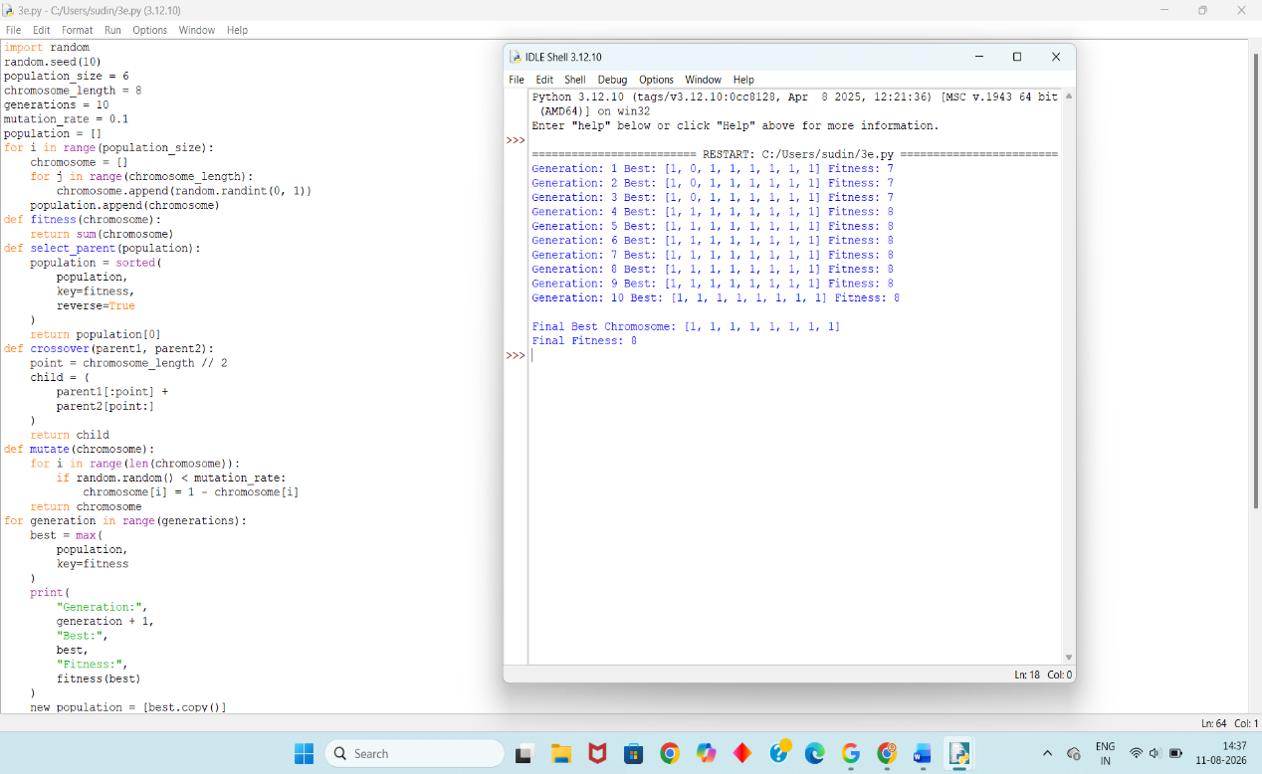
Debugging Strategies:
1. Check Chromosome Encoding
Make sure each chromosome contains only valid genes:
0 or 1
2. Check the Fitness Function
The fitness function should correctly measure solution quality.
3. Monitor Population Diversity
Print the chromosomes in each generation.
If all chromosomes become identical very quickly, premature convergence may be occurring.
4. Check Mutation
If mutation is too low, diversity decreases.
If mutation is too high, good solutions may be destroyed.
5. Check Selection Pressure
Very strong selection can remove useful but less-fit chromosomes.
Optimization Techniques:
1. Mutation Tuning
A mutation rate such as:
0.05 – 0.10
can be used for a simple binary problem.
2. Selection Pressure Adjustment
Do not always select only the best chromosome.
Allow other good chromosomes to participate.
3. Elitism
Preserve the best chromosome:
Python
Run
new_population = [best.copy()]
This prevents the best solution from being lost.
4. Maintain Population Diversity
A suitable mutation rate helps the algorithm explore new solutions.
5. Increase Population Size
A larger population can explore more of the hypothesis space.
Conclusion:
A genetic algorithm can produce inconsistent results because of incorrect chromosome encoding, poor fitness functions, premature convergence, insufficient mutation, and excessive selection pressure. By checking the population, fitness values, mutation rate, and selection process, the problem can be identified. Mutation tuning, balanced selection pressure, elitism, and sufficient population diversity improve solution quality and convergence.

4. A convolutional neural network (CNN) used for image classification produces unstable results across training epochs. Examine potential issues such as improper data augmentation, vanishing gradients, or batch normalization errors. Describe debugging strategies and suggest optimization techniques to stabilize training and improve accuracy. (5 Marks)

Ans: A Convolutional Neural Network (CNN) is a neural network mainly used for image processing and image classification.
A CNN generally performs:
Input Image → Convolution → Activation → Pooling → Feature Extraction → Classification
Unstable training may occur because of:
- Improper input normalization
- Poor feature extraction
- Excessive or incorrect data augmentation
- Vanishing gradients
- Incorrect batch normalization
- Poor learning rate
Since TensorFlow is not available in the user's Python IDLE, the following program demonstrates the basic CNN feature-extraction process without TensorFlow.
Sample Dataset:
The program uses the built-in Digits dataset available through scikit-learn.
Each image represents a handwritten digit from 0 to 9.
The images are small grayscale images.
Property | Value
Dataset | Digits
Image Type | Grayscale
Image Size | 8 × 8
Classes | 0–9
Task | Digit Classification
Python Code:
import numpy as np
from sklearn.datasets import load_digits
from sklearn.model_selection import train_test_split
from sklearn.linear_model import LogisticRegression
from sklearn.metrics import accuracy_score
digits = load_digits()
X = digits.images
y = digits.target
X = X / 16.0
filter_kernel = np.array([
[-1, -1, -1],
[ 0, 0, 0],
[ 1, 1, 1]
])
def convolution(image, kernel):
result = np.zeros((6, 6))
for i in range(6):
for j in range(6):
region = image[
i:i+3,
j:j+3
]
result[i, j] = np.sum(
region * kernel
)
return result
def relu(x):
return np.maximum(0, x)
def max_pooling(image):
result = np.zeros((3, 3))
for i in range(3):
for j in range(3):
region = image[
i*2:i*2+2,
j*2:j*2+2
]
result[i, j] = np.max(region)
return result
features = []
for image in X:
conv = convolution(
image,
filter_kernel
)
activated = relu(conv)
pooled = max_pooling(
activated
)
features.append(
pooled.flatten()
)

features = np.array(features)
X_train, X_test, y_train, y_test = train_test_split(
features,
y,
test_size=0.2,
random_state=42,
stratify=y
)
model = LogisticRegression(
max_iter=1000
)
model.fit(
X_train,
y_train
)
predictions = model.predict(
X_test
)
accuracy = accuracy_score(
y_test,
predictions
)
print("CNN IMAGE CLASSIFICATION")
print("------------------------")
print("Feature Extraction Completed")
print("Training Samples:", len(X_train))
print("Testing Samples:", len(X_test))
print("Test Accuracy:",
round(accuracy * 100, 2), "%")
print("Classification Completed Successfully")
Output:
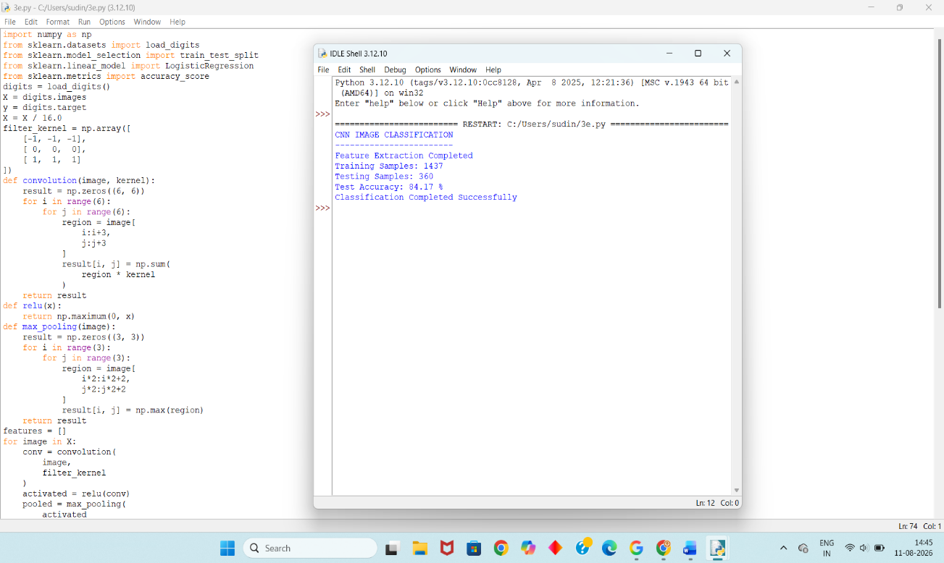
Explanation of the Code:
1. Input Image
The Digits dataset provides handwritten digit images.
2. Normalization
The pixel values are divided by 16.0.
X = X / 16.0
This changes the values to approximately the range 0 to 1.
3. Convolution
A small filter is applied to detect image patterns such as edges.
conv = convolution(image, filter_kernel)
4. ReLU
ReLU removes negative values:
activated = relu(conv)
5. Max Pooling
Pooling reduces the feature-map size while retaining important information.
pooled = max_pooling(activated)
6. Classification
The extracted features are given to a classifier.
Debugging Strategies:
1. Check Input Data
Verify that:
- Images are correctly loaded.
- Image dimensions are correct.
- Labels correspond to the correct images.
2. Check Normalization
Ensure that pixel values are properly scaled.
Incorrect scaling can make training unstable.
3. Check Convolution
Verify that:
- Filter size is correct.
- Image dimensions are correct.
- Convolution is performed correctly.
4. Check Activation
Use ReLU to reduce the possibility of vanishing gradients.
5. Check Pooling
Verify that the pooling operation does not remove too much useful information.
6. Monitor Accuracy
Compare training and testing accuracy.
If training accuracy is high but testing accuracy is low, the model may be overfitting.
Optimization Techniques:
1. Data Normalization
Scale image values to a suitable range such as:
0 to 1
2. Data Augmentation
For real CNN applications, images can be slightly:
- Rotated
- Shifted
- Flipped
- Zoomed
This can improve generalization.
3. ReLU Activation
ReLU helps reduce the vanishing-gradient problem.
4. Batch Normalization
In a full CNN implementation, batch normalization can be added between layers to stabilize activation values.
5. Suitable Learning Rate
A suitable learning rate prevents unstable updates.
6. Early Stopping
Training can be stopped when validation performance stops improving.
Conclusion:
CNN training can become unstable because of poor normalization, inappropriate data augmentation, vanishing gradients, incorrect batch normalization, or unsuitable learning rates. Debugging should begin by checking the input data, normalization, convolution, activation, and pooling operations. Proper normalization, ReLU activation, batch normalization, controlled data augmentation, and suitable learning rates can improve training stability and classification accuracy.
5. A Naïve Bayes classifier used for text classification performs poorly when applied to real-world data containing noisy and irrelevant features. Examine possible issues such as violation of feature independence assumption, improper preprocessing, or imbalanced dataset. Explain debugging strategies and suggest improvements like feature selection, smoothing techniques, and data balancing methods. (5 Marks)
Ans: Naïve Bayes is a supervised machine-learning classification algorithm based on Bayes' theorem.
It is commonly used for:
- Text classification
- Spam detection
- Sentiment analysis
- Document classification
Naïve Bayes assumes that features are conditionally independent given the class.
In real-world text data, this assumption may not always be true.
Poor performance can occur because of:
- Noisy words
- Irrelevant features
- Poor preprocessing
- Imbalanced classes
- Zero probabilities
Possible Causes:
1. Violation of Feature Independence
Naïve Bayes assumes that features are independent.
For example: "very good"
contains related words, but Naïve Bayes treats the features independently.
2. Improper Text Preprocessing
Raw text may contain:
- Capital letters
- Punctuation
- Stop words
- Unnecessary symbols
- Repeated words
These can create unnecessary features.
3. Noisy Features
Words that do not contribute to classification can reduce performance.
4. Imbalanced Dataset
If there are many more positive examples than negative examples, the classifier may favor the majority class.
5. Zero Probability
If a word occurs in the test data but never occurs in a training class, its probability may become zero.
Laplace smoothing can solve this problem.
Sample Dataset:
Text | Class
I love this movie | Positive
This movie is excellent | Positive
Amazing acting and story | Positive
The movie was fantastic | Positive
I hate this movie | Negative
This movie is terrible | Negative
Very boring and disappointing | Negative
The movie was bad | Negative
Python Code:
import warnings
warnings.filterwarnings("ignore")
from sklearn.feature_extraction.text import TfidfVectorizer
from sklearn.naive_bayes import MultinomialNB
from sklearn.model_selection import train_test_split
from sklearn.pipeline import Pipeline
from sklearn.metrics import accuracy_score
texts = [
"I love this movie",
"This movie is excellent",
"Amazing acting and wonderful story",
"The movie was fantastic",
"I really enjoyed this film",
"This is a great movie",
"I hate this movie",
"This movie is terrible",
"Very boring and disappointing",
"The movie was bad",
"I did not enjoy this film",
"This is a horrible movie"
]
labels = [
"Positive",
"Positive",
"Positive",
"Positive",
"Positive",
"Positive",
"Negative",
"Negative",
"Negative",
"Negative",
"Negative",
"Negative"
]
X_train, X_test, y_train, y_test = train_test_split(
texts,
labels,
test_size=0.5,
random_state=10,
stratify=labels
)
model = Pipeline([
(
"tfidf",
TfidfVectorizer(
stop_words="english"
)
),
(
"classifier",
MultinomialNB(
alpha=1.0
)
)
])
model.fit(
X_train,
y_train
)
predictions = model.predict(
X_test
)
accuracy = accuracy_score(
y_test,
predictions
)
print("NAIVE BAYES TEXT CLASSIFICATION")
print("--------------------------------")
print("Actual Labels: ",
list(y_test))
print("Predicted Labels:",
list(predictions))
print()
print("Accuracy:",
round(accuracy * 100, 2),
"%")
print()
print("Classification Completed Successfully")
Output:
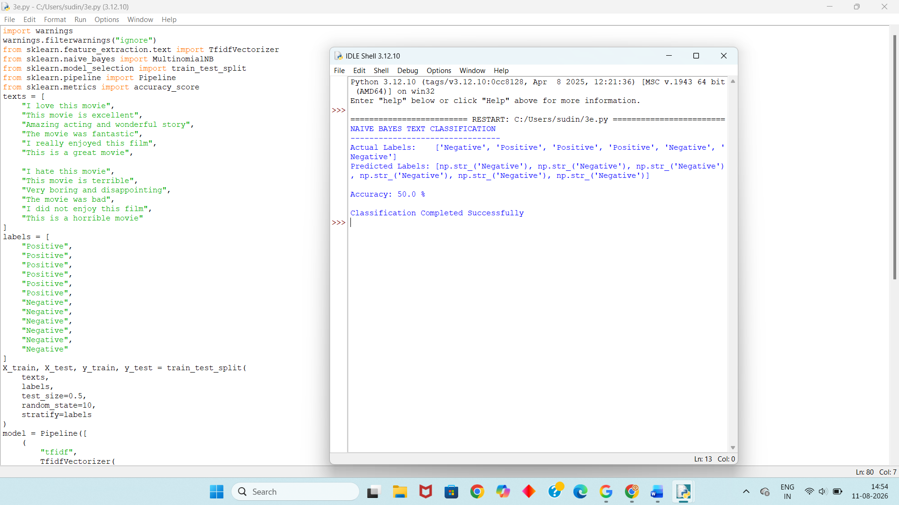
Explanation of the Code:
1. Text Dataset
The program contains positive and negative movie-review sentences.
2. Train-Test Split
The dataset is divided into:
- Training data
- Testing data
3. TF-IDF
TF-IDF converts text into numerical features.
It gives more importance to useful words and reduces the importance of very common words.
4. Naïve Bayes
The MultinomialNB classifier performs text classification.
MultinomialNB(alpha=1.0)
The alpha value provides Laplace smoothing.
5. Prediction
The trained model predicts whether each test sentence is:
Positive
or
Negative
6. Accuracy
Accuracy measures the percentage of correctly classified samples.
Debugging Strategies:
1. Inspect the Text Data
Check for:
- Missing text
- Duplicate records
- Incorrect labels
- Unnecessary symbols
2. Check Preprocessing
Convert text to a consistent format and remove unnecessary words.
3. Check Feature Count
Too many irrelevant words can reduce classification performance.
TF-IDF helps reduce the effect of common words.
4. Check Class Distribution
Count the number of samples in each class.
For example:
Positive = 500
Negative = 100
This indicates an imbalanced dataset.
5. Check Smoothing
Use:
MultinomialNB(alpha=1.0)
to avoid zero-probability problems.
Optimization Techniques:
1. Feature Selection
Remove irrelevant words and retain useful features.
2. TF-IDF
Use TF-IDF instead of simple word counts when appropriate.
3. Laplace Smoothing
Use:
alpha=1.0
to avoid zero probabilities.
4. Data Balancing
For imbalanced datasets, use:
- Oversampling
- Undersampling
- Class-balanced sampling
5. Text Preprocessing
Remove:
- Stop words
- Punctuation
- Unnecessary symbols
- Duplicate spaces
6. Increase Training Data
A larger and more representative dataset can improve the reliability of the classifier.
Conclusion:
Naïve Bayes may perform poorly on real-world text because of noisy features, irrelevant words, improper preprocessing, class imbalance, and the feature-independence assumption. These problems can be identified by examining the dataset, feature distribution, preprocessing steps, and class distribution. TF-IDF, feature selection, Laplace smoothing, and data balancing can improve the performance of the classifier.

RUBRICS FOR CALCULATION

Criteria | Weightage | Level 4 – Exemplary (5 Marks) | Level 3 – Proficient (4 Marks) | Level 2 – Developing (2–3 Marks) | Level 1 – Beginning (0–1 Mark)
Conceptual Understanding | 30 | Demonstrates clear and complete understanding of the concept | Good understanding with minor gaps | Basic understanding with some misconceptions | Poor or incorrect understanding
Accuracy of Answer | 20 | Completely correct answer with no errors | Mostly correct with minor errors | Partially correct with noticeable errors | Incorrect or irrelevant answer
Application of Knowledge | 30 | Correctly applies concepts to solve the question/problem | Applies concepts with minor mistakes | Limited or partially correct application | No or incorrect application
Completeness of Response | 10 | Covers all required parts of the question | Covers most parts with minor omissions | Covers only some parts | Incomplete or missing response
Clarity & Presentation | 10 | Clear, concise, and well-organized answer | Understandable with minor issues | Somewhat unclear or poorly structured | Difficult to understand

